MySQL

1. Total sales

select sum(invoiceline.UnitPrice*invoiceline.Quantity) AS total_sales from invoiceline

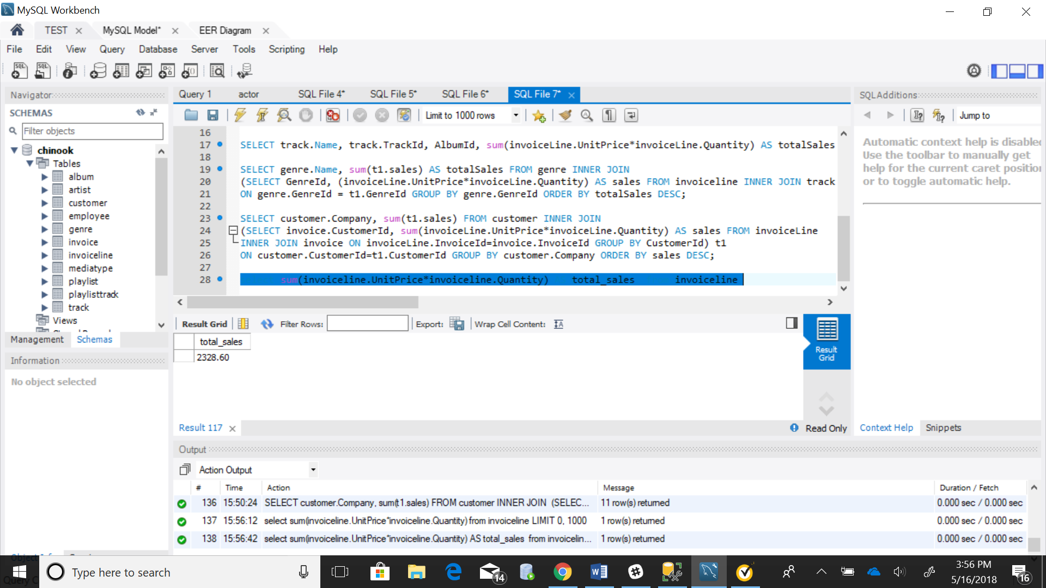

2. Total sales $ by country – ranked (or at least sorted largest to smallest)

select invoice.billingcountry, sum(total) as Sales

from invoice

group by billingcountry

order by sales desc

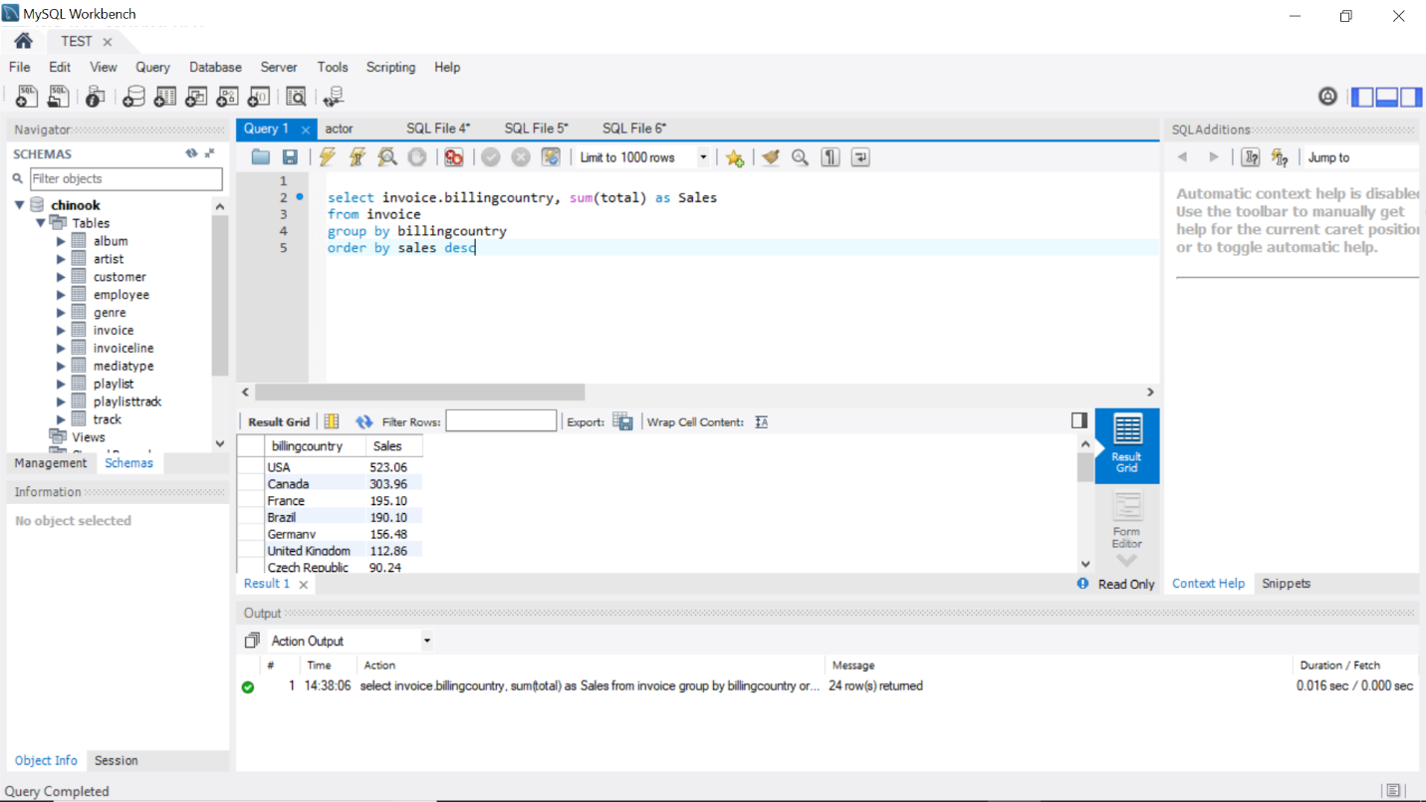  
3. Total sales by country, states and city

select invoice.billingcountry, invoice.BillingState, invoice.BillingCity, sum(total) as Sales

from invoice

group by billingcountry

order by sales desc

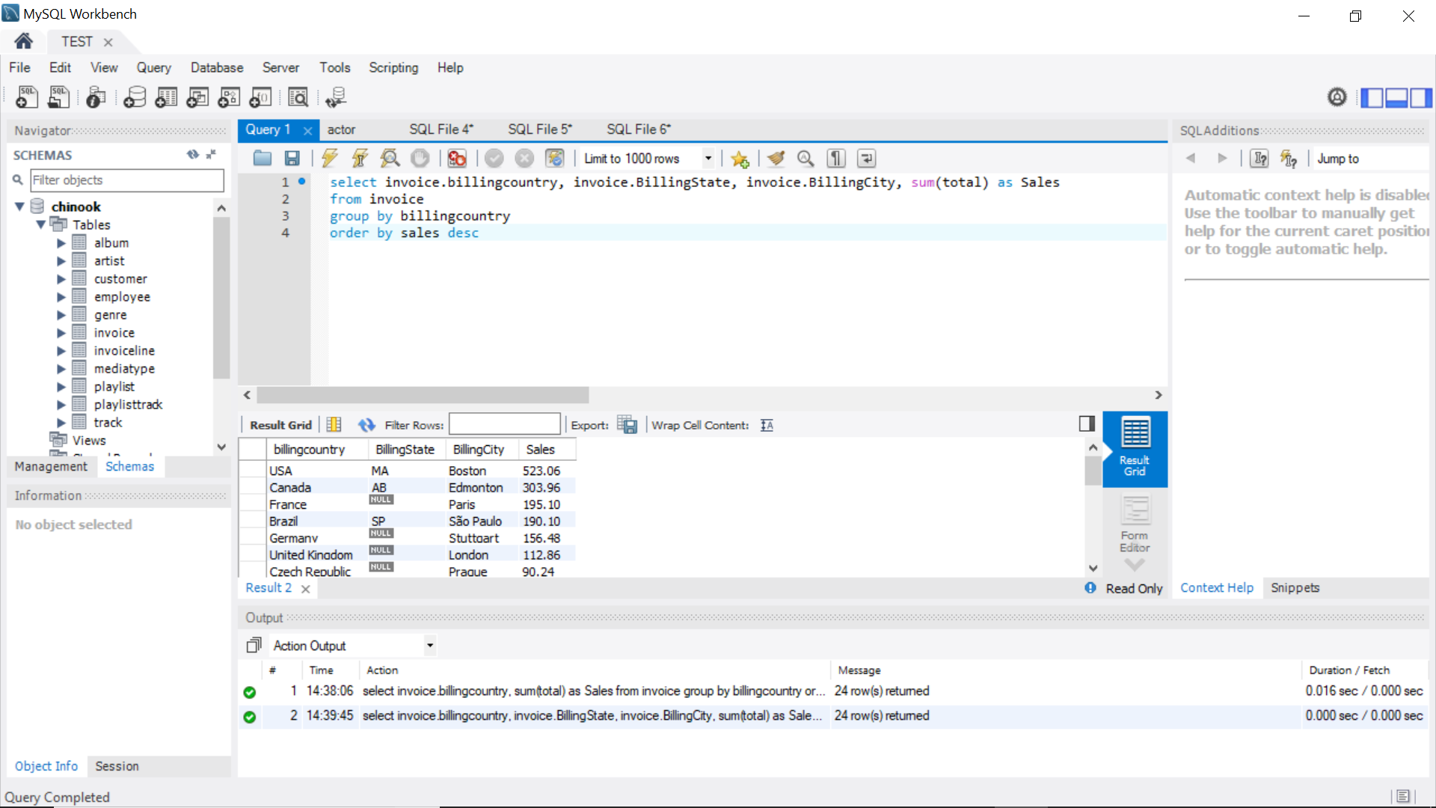

4 Total sales by customer

select c.FirstName, c.LastName as Lastname, i.total

from invoice i, customer c

where i.CustomerId = c.SupportRepId

group by lastname;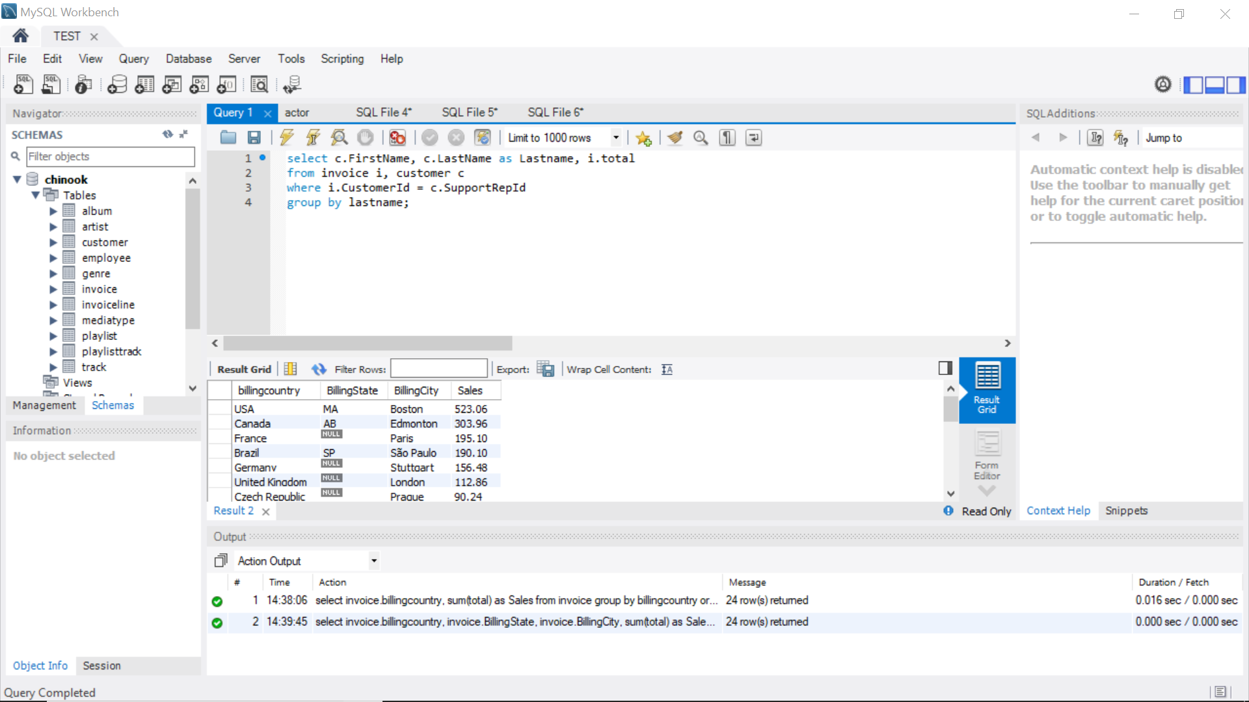

5 Total sales by artist

SELECT artist.Name, sum(t2.UnitPrice) AS totalSales FROM artist INNER JOIN

(SELECT album.AlbumId, album.ArtistId, t1.UnitPrice FROM album

INNER JOIN

(SELECT track.TrackId, AlbumId, invoiceLine.UnitPrice FROM invoiceLine INNER JOIN track ON invoiceLine.TrackId = track.TrackId) AS t1

ON album.AlbumId = t1.AlbumId) AS t2

ON artist.ArtistId=t2.ArtistId GROUP BY artist.ArtistId ORDER BY totalSales DESC;

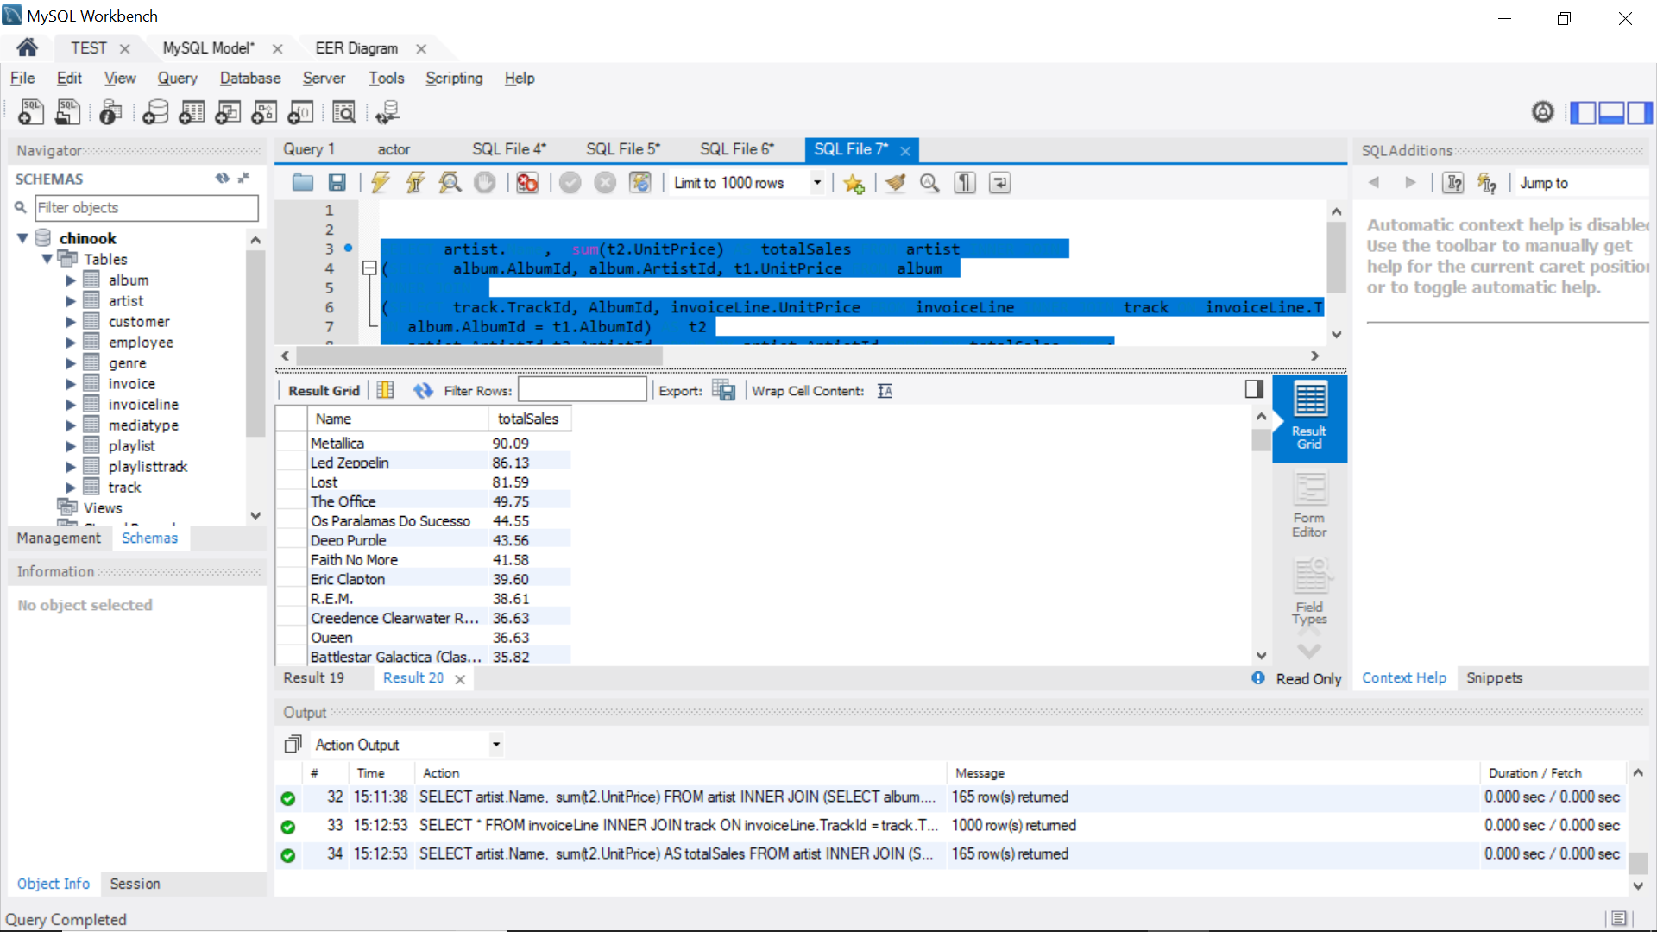

6 Total sales by albums

SELECT album.Title, t1.totalSales FROM album INNER JOIN

(SELECT track.TrackId, AlbumId, sum(invoiceLine.UnitPrice*invoiceLine.Quantity) AS totalSales FROM invoiceLine INNER JOIN track ON invoiceLine.TrackId = track.TrackId GROUP BY AlbumId) AS t1

ON t1.AlbumID=album.AlbumId GROUP BY t1.AlbumId ORDER BY totalSales DESC;

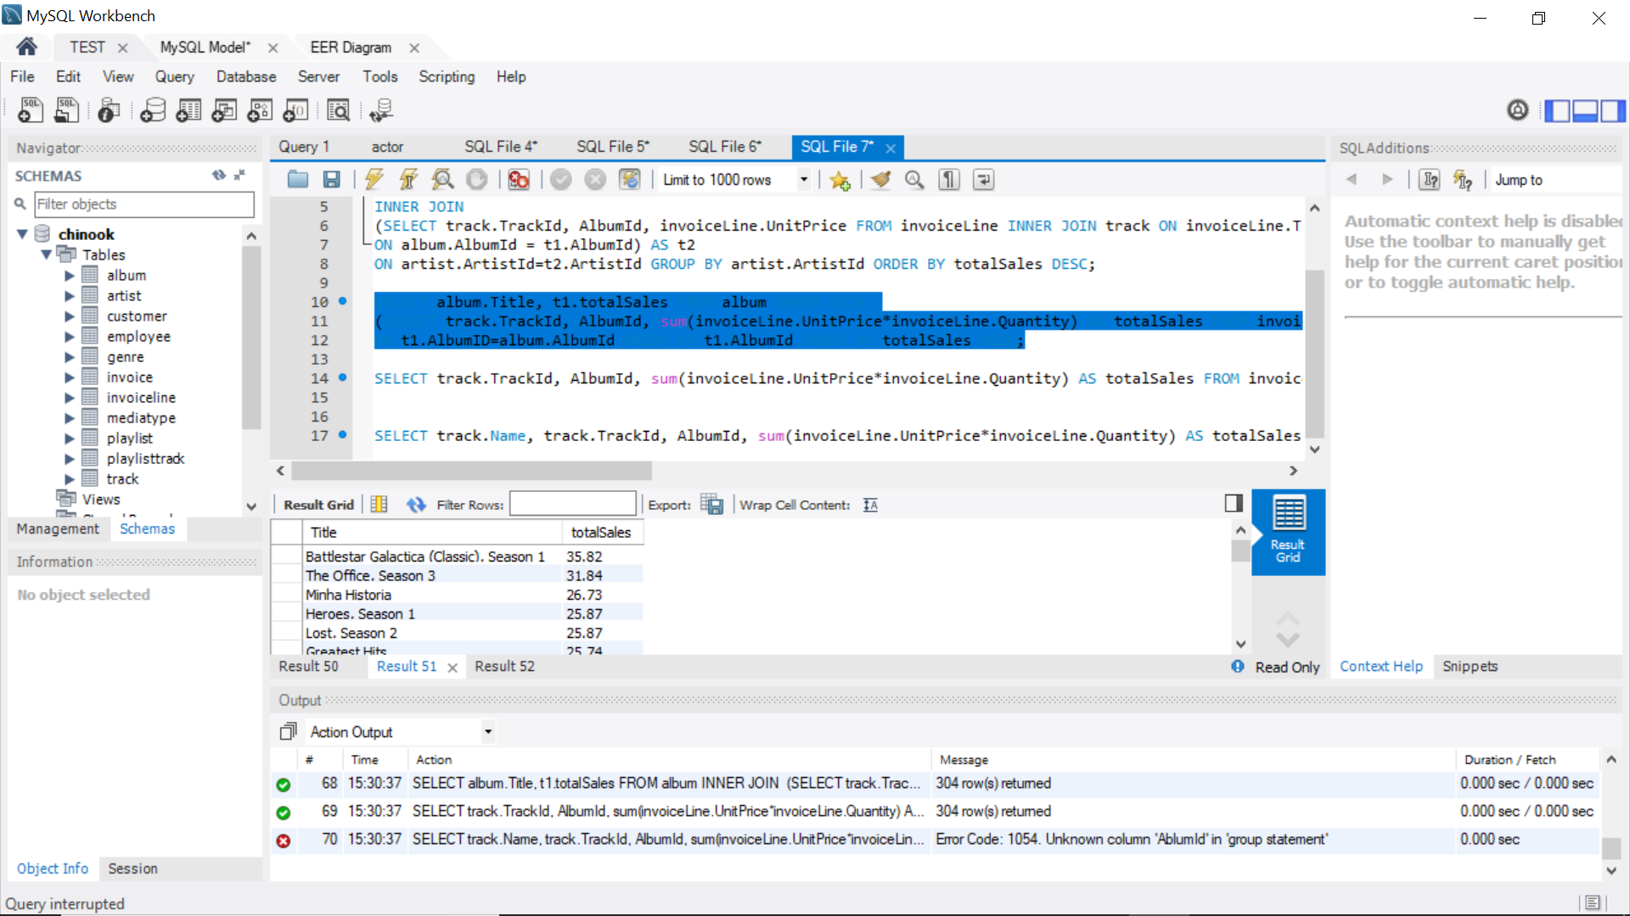

7 Total sales by sales person

SELECT Employee.FirstName, Employee.LastName, SUM(Invoice.Total) FROM Invoice

INNER JOIN Customer ON Customer.CustomerId = Invoice.CustomerId

INNER JOIN Employee ON Employee.EmployeeId = Customer.SupportRepId

GROUP BY Employee.EmployeeId

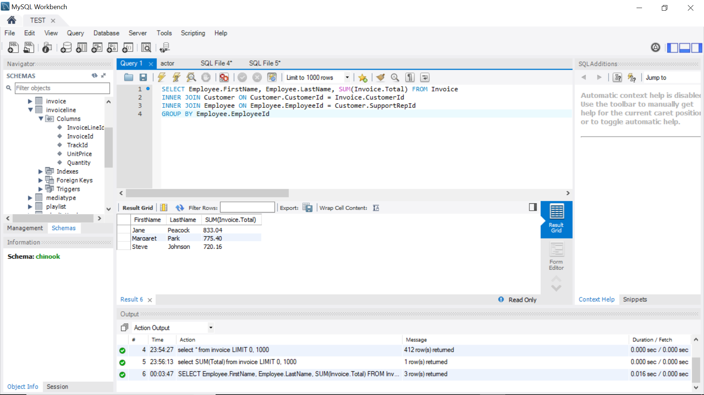

8.Total track bought and total revenue by media type:

select count(trackid), MediaTypeId from track

group by MediaTypeId;

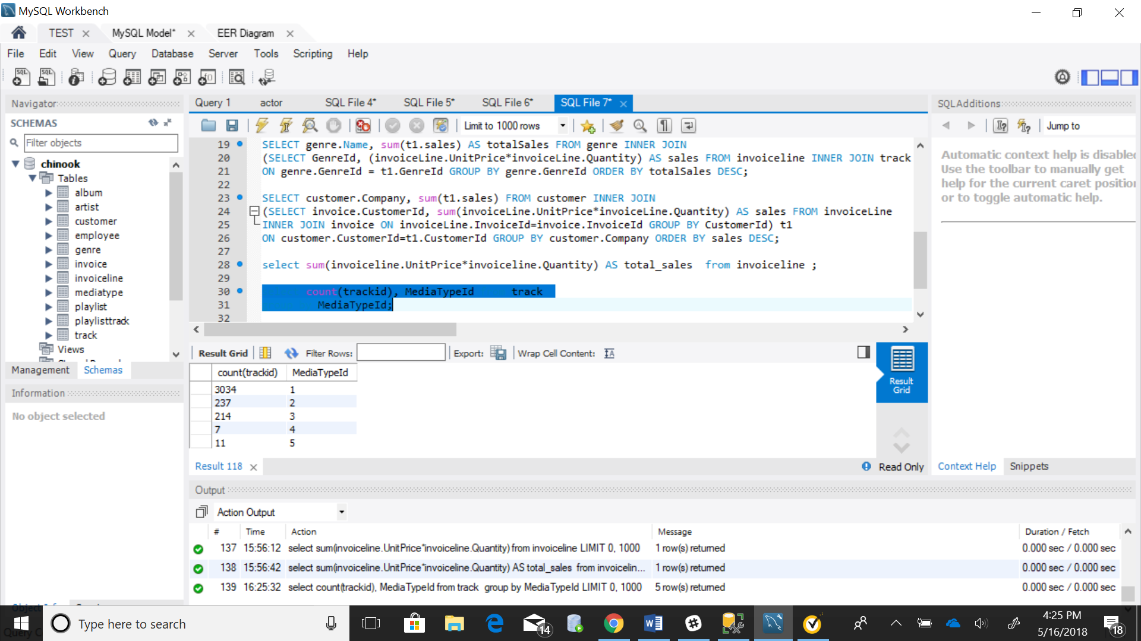

(select track.mediatypeid, sum(invoiceline.UnitPrice*invoiceline.Quantity) as revenue from invoiceline

inner join track on track.trackid = invoiceline.trackid group by mediatypeid)

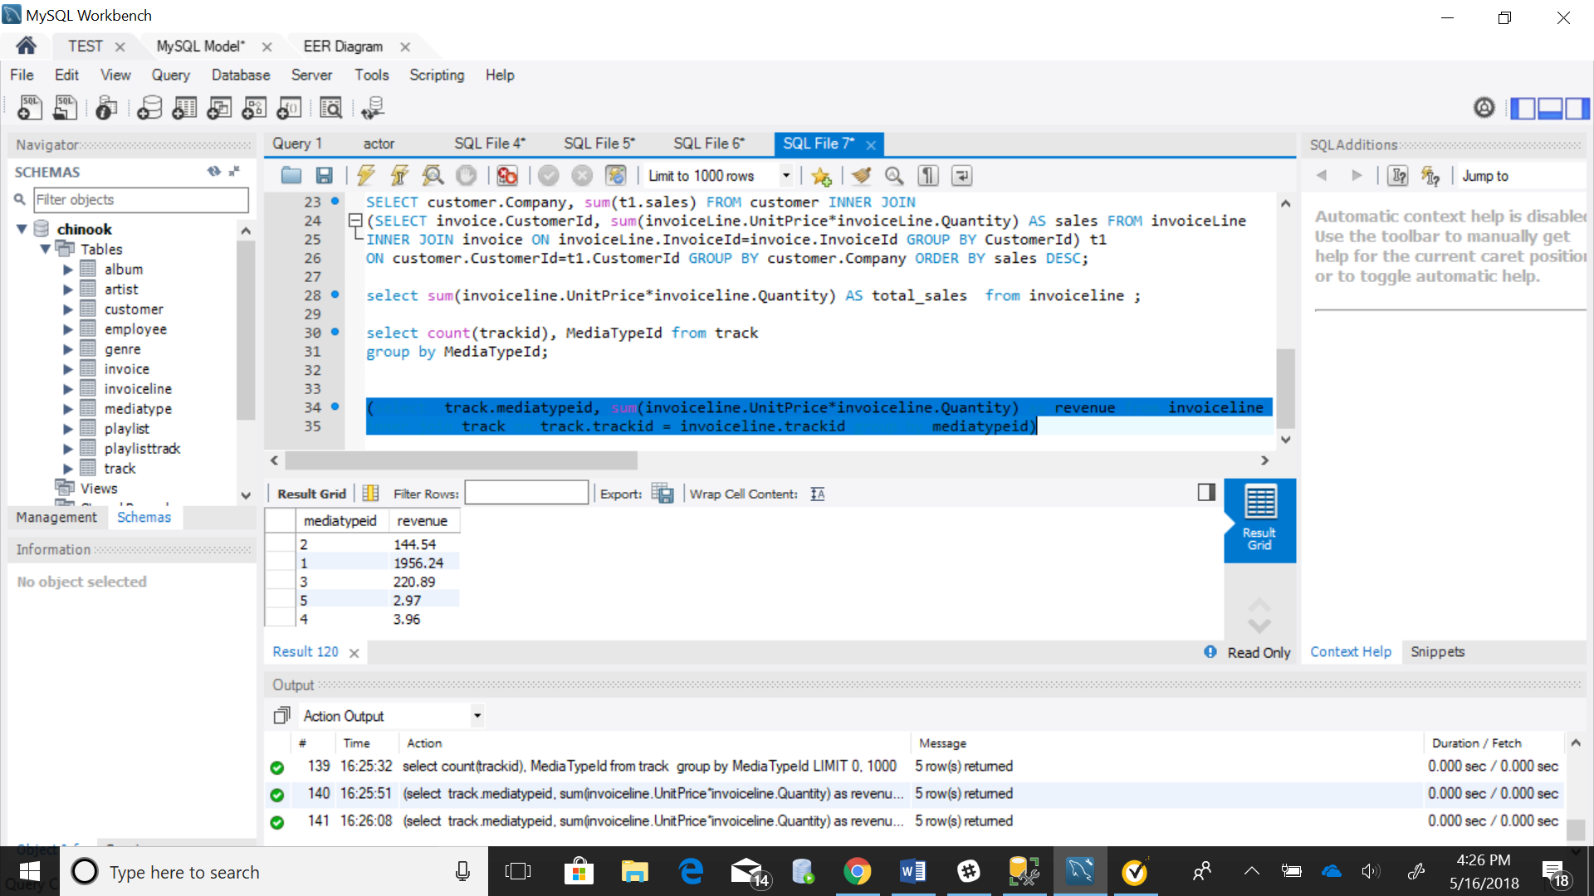

9.Total sales by genre

SELECT genre.Name, sum(t1.sales) AS totalSales FROM genre INNER JOIN

(SELECT GenreId, (invoiceLine.UnitPrice*invoiceLine.Quantity) AS sales FROM invoiceline INNER JOIN track ON invoiceLine.TrackId=track.TrackId GROUP BY track.TrackId) t1

ON genre.GenreId = t1.GenreId GROUP BY genre.GenreId ORDER BY totalSales DESC;

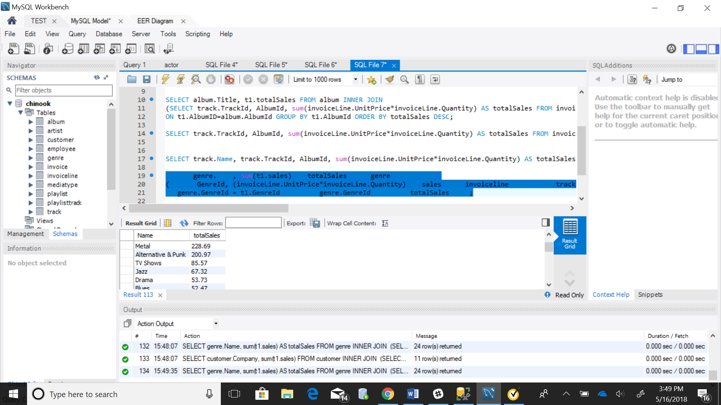

10. Total sales by company

SELECT customer.Company, sum(t1.sales) FROM customer INNER JOIN

(SELECT invoice.CustomerId, sum(invoiceLine.UnitPrice*invoiceLine.Quantity) AS sales FROM invoiceLine

INNER JOIN invoice ON invoiceLine.InvoiceId=invoice.InvoiceId GROUP BY CustomerId) t1

ON customer.CustomerId=t1.CustomerId GROUP BY customer.Company ORDER BY sales DESC;

